COMMIT

🧾 What is COMMIT?
# Source: AI Source: Provided by: [Data Path: Persons Table -> ID Column: 1, Name_En Column: Motasem Essam] -> From: [ChatGPT] on [6/11/2026]
COMMIT is a TCL (Transaction Control Language) command that is used to permanently save all the changes made by the current transaction to the database.
Once a COMMIT is issued:
- The changes become visible to other users.
- The changes cannot be rolled back.
✅ Syntax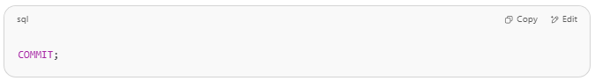
COMMIT;

📌 When to Use COMMIT
# Source: AI Source: Provided by: [Data Path: Persons Table -> ID Column: 1, Name_En Column: Motasem Essam] -> From: [ChatGPT] on [6/11/2026]
Use COMMIT when:
- You’ve completed a series of related operations successfully.
- You want to make your changes permanent.
- You’ve finished a logical unit of work.

🧪 Example Scenario

Step 1: Turn off autocommit (in MySQL)
# Source: AI Source: Provided by: [Data Path: Persons Table -> ID Column: 1, Name_En Column: Motasem Essam] -> From: [ChatGPT] on [6/11/2026]
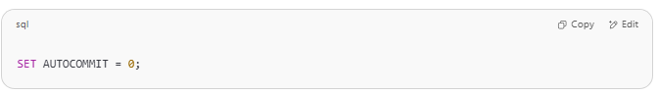
SET AUTOCOMMIT = 0;

Step 2: Start transaction with changes
# Source: AI Source: Provided by: [Data Path: Persons Table -> ID Column: 1, Name_En Column: Motasem Essam] -> From: [ChatGPT] on [6/11/2026]
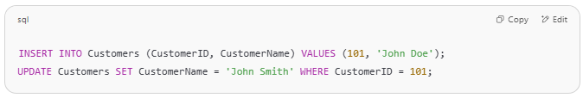
INSERT INTO Customers (CustomerID, CustomerName) VALUES (101, 'John Doe');
UPDATE Customers SET CustomerName = 'John Smith' WHERE CustomerID = 101;

Step 3: Save changes
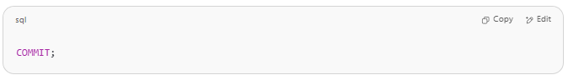
COMMIT;

🟢 The insert and update are now permanent.

🔁 Without COMMIT
# Source: AI Source: Provided by: [Data Path: Persons Table -> ID Column: 1, Name_En Column: Motasem Essam] -> From: [ChatGPT] on [6/11/2026]
If you do not use COMMIT, and the session ends or you issue ROLLBACK, all uncommitted changes will be discarded.

⚠️ Key Notes
# Source: AI Source: Provided by: [Data Path: Persons Table -> ID Column: 1, Name_En Column: Motasem Essam] -> From: [ChatGPT] on [6/11/2026]
- Once you COMMIT, you cannot roll back.
- Use with care — especially in bulk operations.
- Many database systems AUTOCOMMIT by default. You must disable it if you want to control transactions manually.

💡 Quick Test Query
# Source: AI Source: Provided by: [Data Path: Persons Table -> ID Column: 1, Name_En Column: Motasem Essam] -> From: [ChatGPT] on [6/11/2026]
Try this in MySQL:
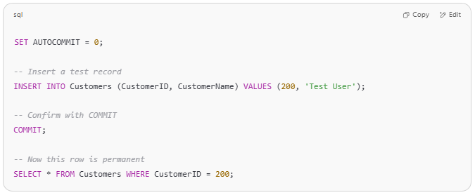
SET AUTOCOMMIT = 0;

-- Insert a test record
INSERT INTO Customers (CustomerID, CustomerName) VALUES (200, 'Test User');

-- Confirm with COMMIT
COMMIT;

-- Now this row is permanent
SELECT * FROM Customers WHERE CustomerID = 200;

Example

prepared commands
# Source: ScreenShot Source: Provided by: [Persons Table -> ID Column: 1, Name_En Column: Motasem Essam] -> Tool: [Automation Table -> ID Column: 16, Name_En Column: Screen Capture] -> From [Operating System: Wampserver64 -> phpmyadmin] on [6/11/2026]

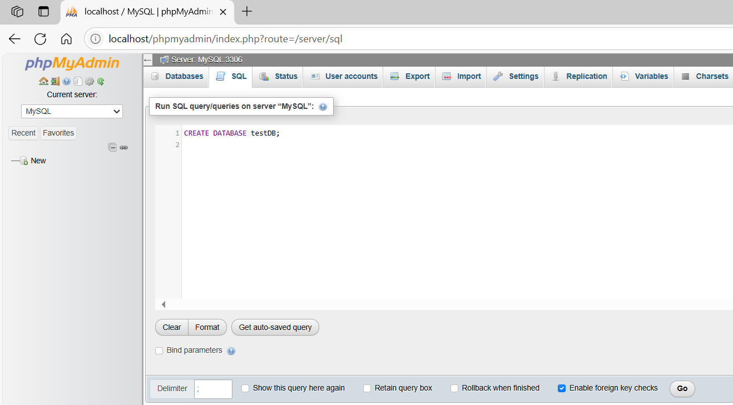
CREATE DATABASE testDB;
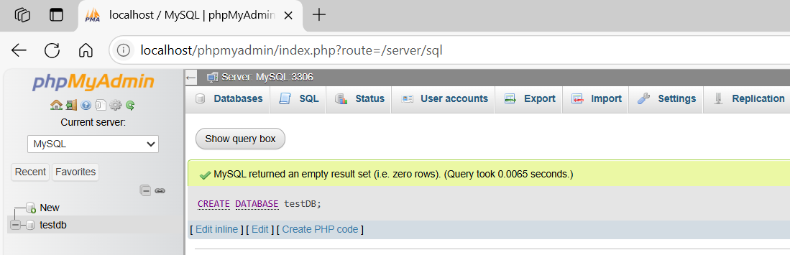
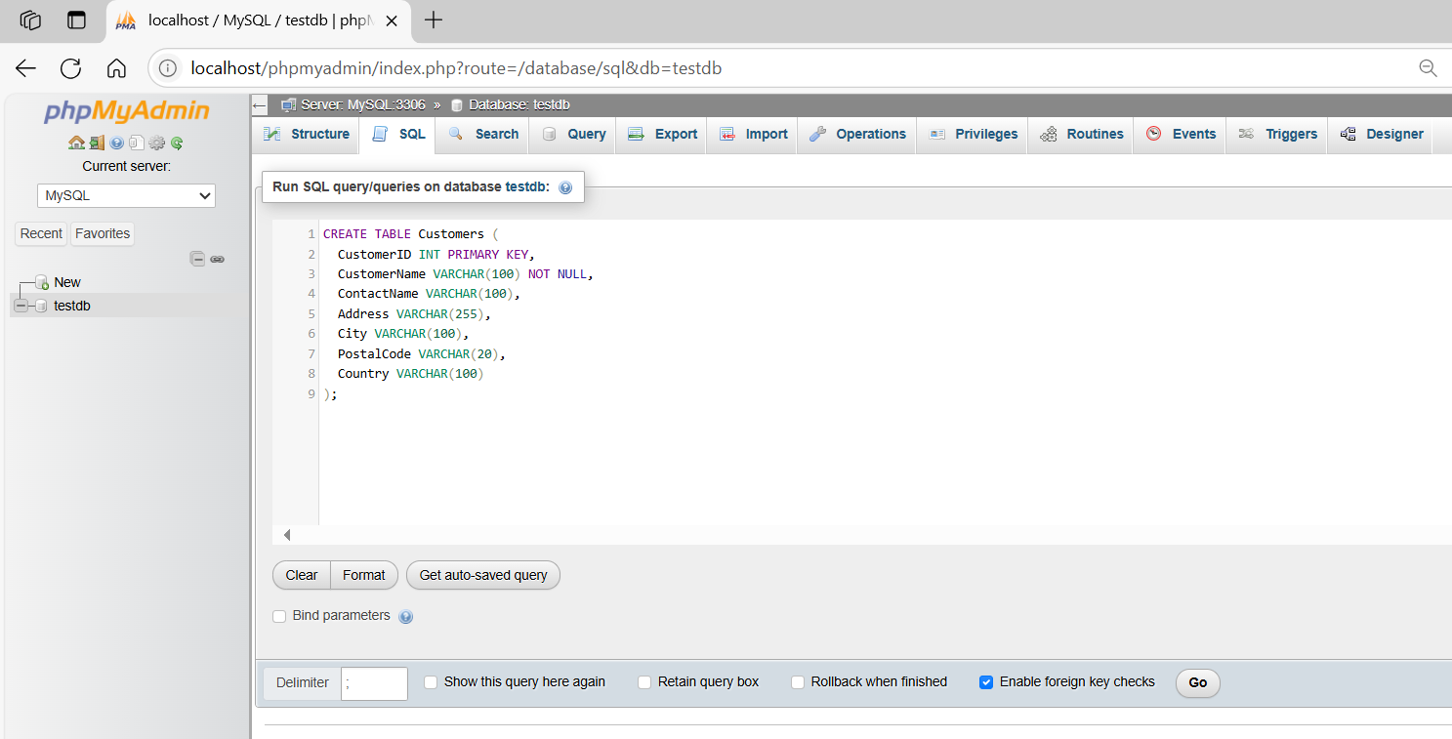
CREATE TABLE Customers (
CustomerID INT PRIMARY KEY,
CustomerName VARCHAR(100) NOT NULL,
ContactName VARCHAR(100),
Address VARCHAR(255),
City VARCHAR(100),
PostalCode VARCHAR(20),
Country VARCHAR(100)
);
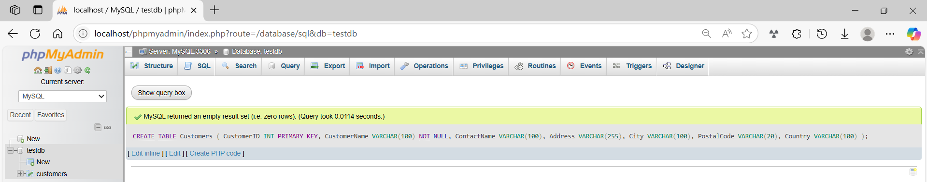
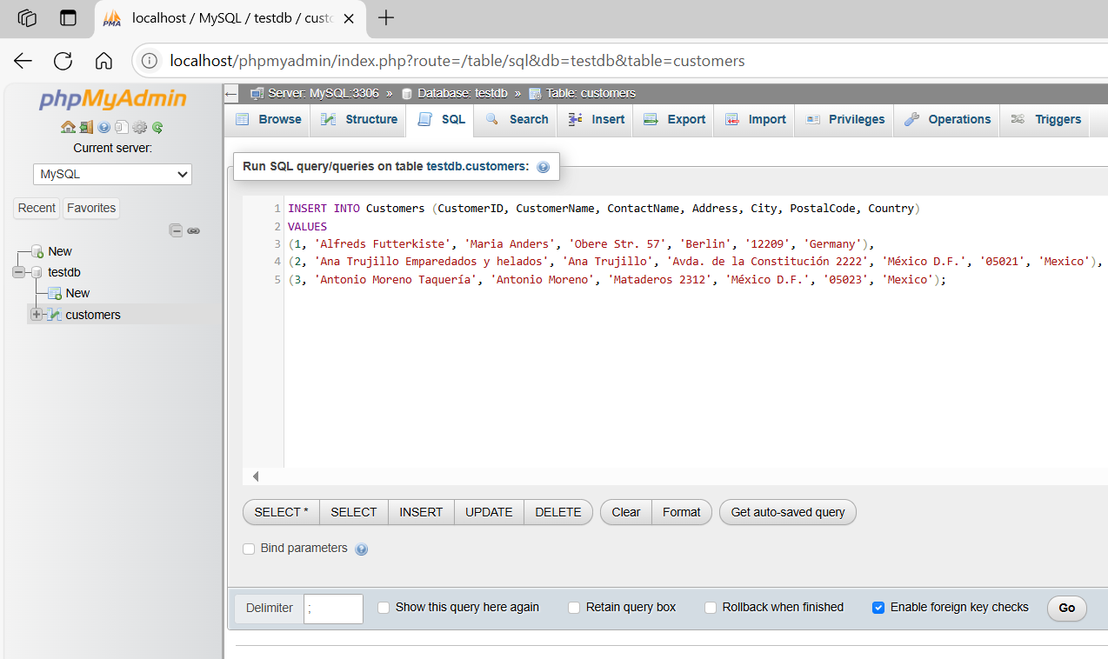
INSERT INTO Customers (CustomerID, CustomerName, ContactName, Address, City, PostalCode, Country)
VALUES
(1, 'Alfreds Futterkiste', 'Maria Anders', 'Obere Str. 57', 'Berlin', '12209', 'Germany'),
(2, 'Ana Trujillo Emparedados y helados', 'Ana Trujillo', 'Avda. de la Constitución 2222', 'México D.F.', '05021', 'Mexico'),
(3, 'Antonio Moreno Taquería', 'Antonio Moreno', 'Mataderos 2312', 'México D.F.', '05023', 'Mexico');
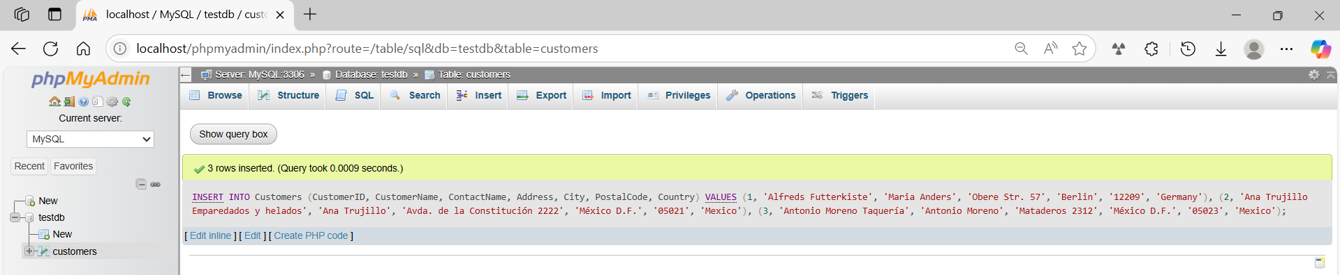
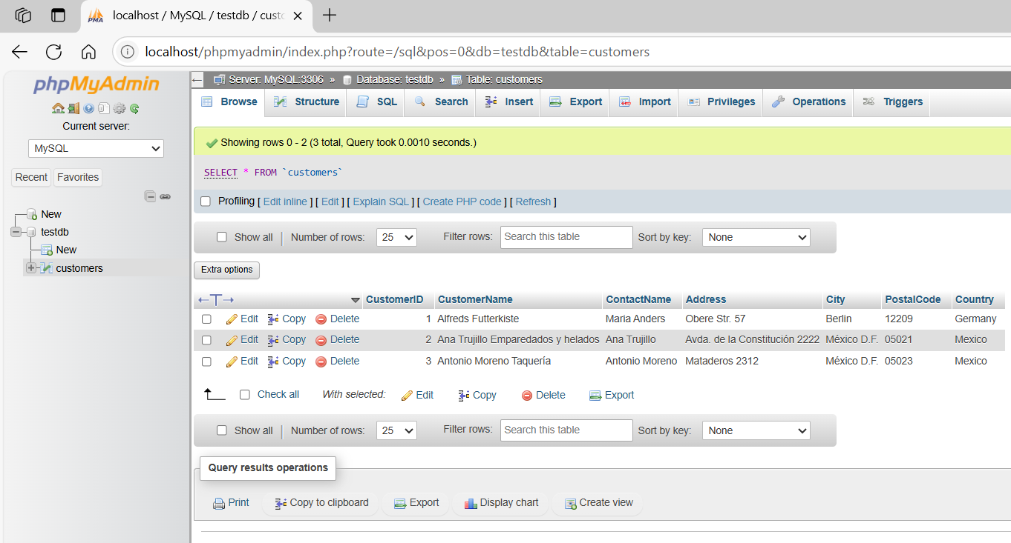

basic command
# Source: ScreenShot Source: Provided by: [Persons Table -> ID Column: 1, Name_En Column: Motasem Essam] -> Tool: [Automation Table -> ID Column: 16, Name_En Column: Screen Capture] -> From [Operating System: Wampserver64 -> phpmyadmin] on [6/11/2026]
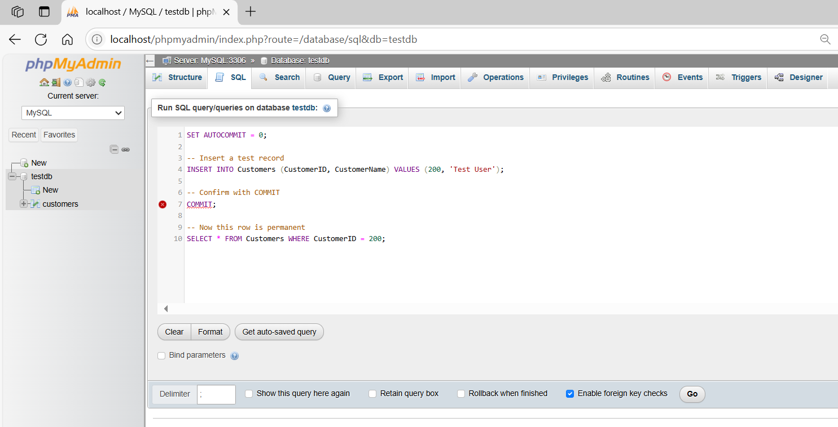
SET AUTOCOMMIT = 0;

-- Insert a test record
INSERT INTO Customers (CustomerID, CustomerName) VALUES (200, 'Test User');

-- Confirm with COMMIT
COMMIT;

-- Now this row is permanent
SELECT * FROM Customers WHERE CustomerID = 200;
